**THE BOARD MEETING OF THE ASSOCIATION OF JUDGES FOR MEDIATION (GEMME)**

***6th NOVEMBER 2021 KRAKÓW, POLAND***

**5th NOVEMBER (FRIDAY) 19:00**

GALA DINNER AT THE WENTZL RESTAURANT AT THE MAIN MARKET SQUARE

*(with the beautiful view for the Main Market Square - the*largest*medieval*square*in Europe.and with grand piano live music).*

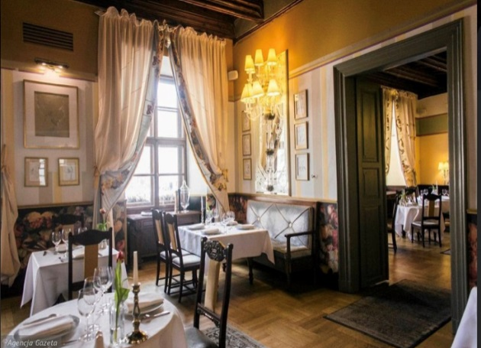

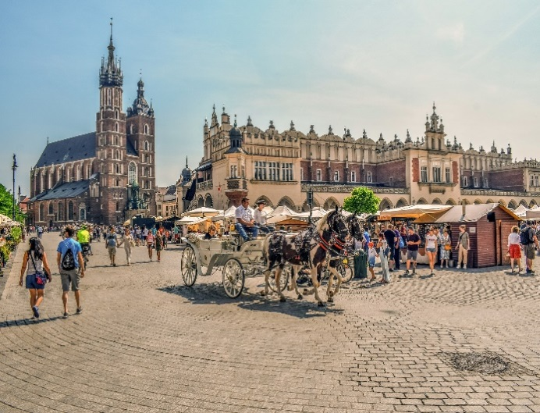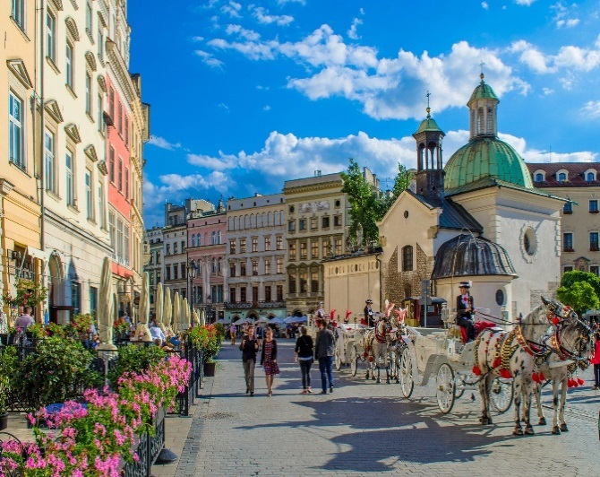*Source: by Wenztl Restaurant.*

P *Source: Pixabay*

*Source: by Pixabay*

**6th NOVEMBER (SATURDAY)**

**Place: Kraków Chamber of Commerce and Industry, Floriańska 3 Street**

*(located just next to the Main Market Square)*

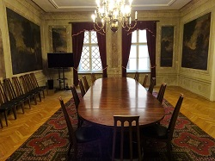

**9:30 – 11:30 COLLOQUIUM**

|  |
| --- |
| „HOW TO PROMOTE MEDIATION?  - the role of judges in mediation & the best practices in EU member countries |

**Opening remarks:** Rosalia Fernandez Alaya, president of GEMME, judge of Provincial Court of Las Palmas, Canary Islands, Spain

1. Are judges allowed in your country to act as mediators?
2. Are judges obliged by law to refer cases to mediation or to conciliate?
3. Are there any circumstances in which mediation is obligatory? If so, please expand.
4. Do you have any court-annexed mediation programmes? What are principles for them? Are they successful?
5. Who bears the cost of mediation? Is there State aided access to mediation in certain circumstances if so please expand.
6. Are lawyers obliged by law to suggest mediation to their clients?
7. Do you have any official statistics about mediaton? If so, please show us the results. How many cases are resolved in mediation and how many cases judges refer to mediation?
8. Any amendments to mediation law in the recent two years?

### **Closing remarks:** Avi Schneebalg, vice –president of GEMME, civil judge in Brussels, Belgium, Conciliation and Mediation Lecturer at IFJ-IGO, EJTN (Belgian and European schools for (future) judges)

Speakers: presidents of national sections of GEMME

**11:30 - 13:30 THE BOARD MEETING**

*Lunch provided*

**AFTER THE BOARD MEETING WE SUGGEST:**

1. **VISIT TO THE COLLEGIUM MAIUS** *(Latin for „Great College”)* **MUSEUM**

*(only 5 people can enter in the same time, the last entrance is at 14:30)*

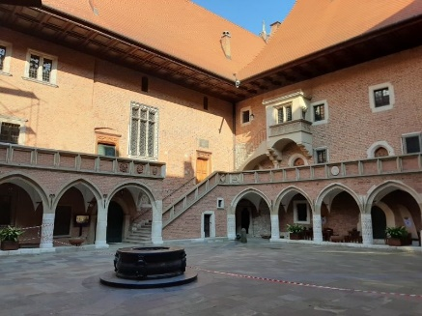It is the Jagiellonian University's oldest building, dating back to the 14th century. The Collegium Maius Museum features lecture rooms, communal halls, professors’ quarters, a library and a treasury containing rectors' Gothic maces and the Jagiellonian globe. Exhibits also include medieval scientific instruments, globes, paintings, collectibles, furniture, coins and medals. It has a splendid late-Gothic edifice around a vast courtyard with surrounding arcades and a well of 1517 in the center. Professors lived and worked upstairs, while lecturing downstairs. In the 1490s they had Copernicus among their students, and the astronomer that revolutionized entire European science remains the most illustrious of Krakow university’s graduates together with Pope John Paul II. Over centuries a whole university quarter has arisen around the Collegium Maius, while the old college became first the university library and then the university museum rich in unrivaled exhibits.

*The ticket price is: 3 EURO*

1. **VISIT TO THE PRINCES CZARTORYSKI MUSEUM**

historic museum, one of the country's oldest museums. The most renowned painting at the Museum is one of **Leonardo da Vinci's best-known works, the** ***Lady with an Ermine*.**

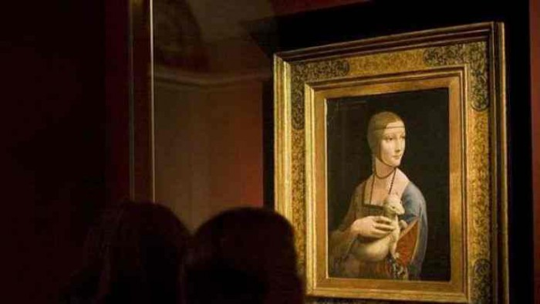

source: https://discovercracow.com/lady-with-an-ermine/ za: krakow.tvp.pl

*The ticket price is: 8 EURO*

1. **VISIT TO JAMA MICHALIKA** **CAFE**

Most famous polish Art Café, traditional polish restaurant and Cabaret Museum “Green Ballon”. Very well known for over one hundred twenty five years. Here most outstanding artists have met, here the cabaret “ Green Ballon” began to exist and here the spirit of „Polish Modernism” was born. The interior is decorated with Art Nouveau furniture, mirrors, stained glass, lamps and cabinets.

*(No host - visit https://jamamichalika.pl/menu/for menu and pricing)*

1. **EVEVNING TOUR AROUND THE MAIN MARKET SQUARE & THE WAWEL ROYAL CASTLE**

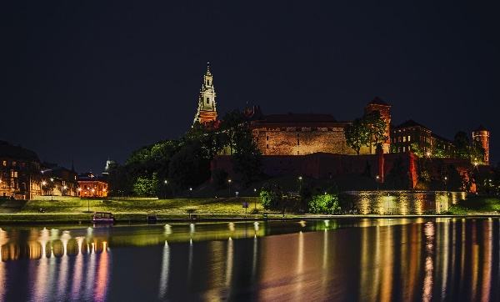 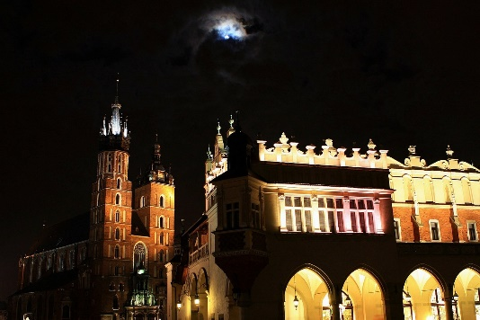

*source: Pixabay*

**7th November (Sunday)**

**10:00 - GUIDED TOUR AT THE WAWEL ROYAL CASTEL**

The Wawel Royal Castle and the Wawel Hill constitute the most historically and culturally important site in Po­land. For centuries the residence of the kings of Poland and the symbol of Polish statehood, the Castle is now one of the country’s premier art museums.

*The ticket price will be given later, depending on how many people will be interested in visiting with the guide.*

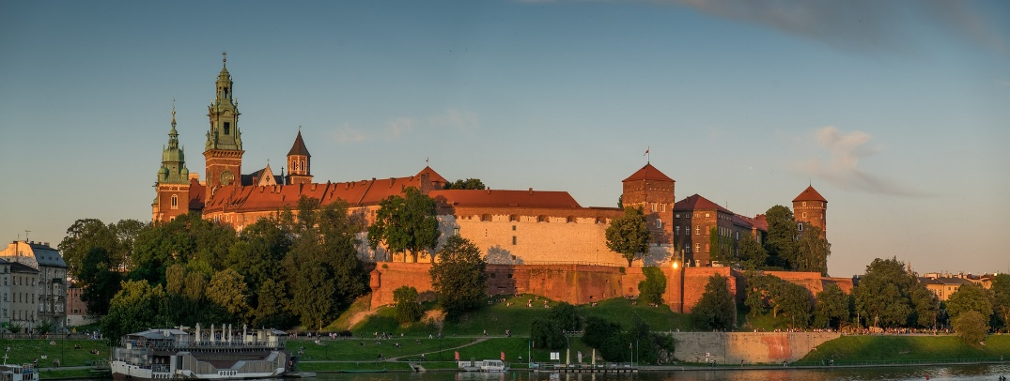

*source: Pixabay*

PLEASE CONFIRM THAT YOU WANT TO ATTEND ANY OF ABOVE MENTIONED EVENTS TO: gemmepolska@gmail.com